**THEME: SETS**

**SET CONCEPTS**

What is a set?

A set is a collection of well-defined members.

**NAMING SETS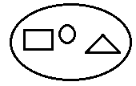 Examples**

1.

A set of 3 shapes

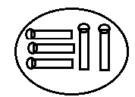

2. A set of 5 match sticks

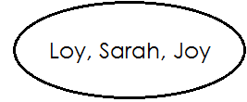

3. A set of 3 names

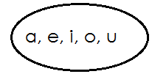**Activity**

1. ______________________________________

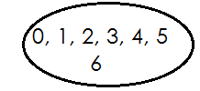

1. 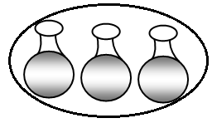______________________________________

3. _______________________________________

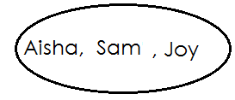

4. _____________________________________

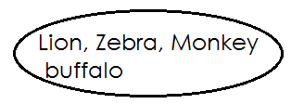

5. _________________________________

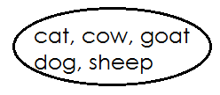

6. ______________________________

**DRAWING SETS**

**Examples**

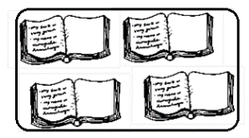1. Draw a set of 4 books

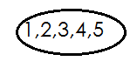2. Draw a set of the first 5 counting numbers

**Activity**

**Draw the sets below**.

1. A set of the first 5 letters of alphabet.

2. A set of 4 trees.

3. A set of 6 balls.

4. A set of 2 cars

5. A set of 3 dolls

6. A set of 6 names

7. A set of 3 birds

8. A set of 4 shapes.

**COUNTING MEMBERS IN A SET**

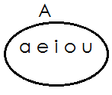 **Examples**

1.

How many members are in set A?

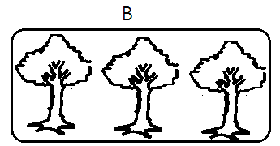Set A has 5 members

2.

How many members are in set B?

There are 3 members in set B

**Activity**

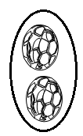 Count the number of members in the sets below

1.

**__________________________________________**

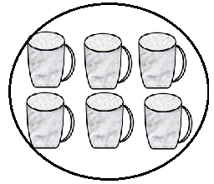

2. _____________________________________

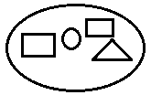

___________________________________

3.

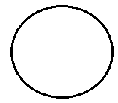

_____________________________________

4.

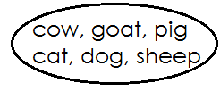

5.  **________________________________**

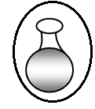

**6.**

**________________________________**

**GROUPING MEMBERS OF A SET**

(a) Grouping members of a set-in twos.

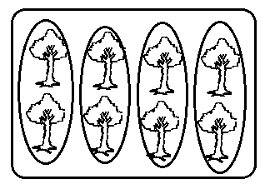 **Examples**

1.

There are **4** groups of **2** trees.

There are **8** trees altogether.

**Activity**

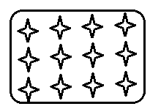Count and pair the members in the sets.

1.

There are _____________ groups of 2 stars.

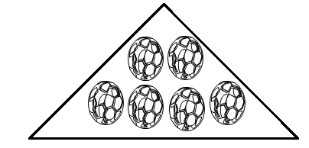There are _____________ stars altogether.

2.

There are ________ groups of 2 balls.

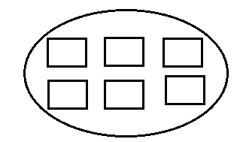There are__________ balls altogether

3.

There are _____________groups of 2 squares

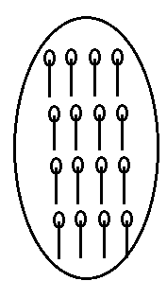There are___________ squares altogether.

4.

There are________ groups of 2 match sticks.

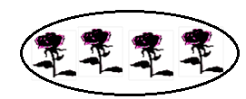There are_________ match sticks altogether.

5.

There are _____groups of 2 trees.

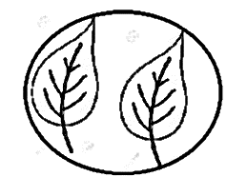There are___________ trees altogether.

6.

,

There is ____________group of 2 leaves.

There are _____________ leaves altogether.

B. **GROUPING MEMBERS OF A SET IN THREES**

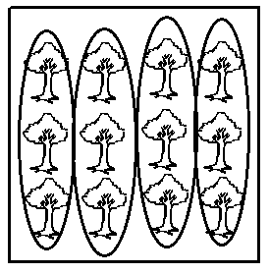 **Examples**

There are ______________groups of 3 trees.

There are ____________trees altogether.

**Activity**

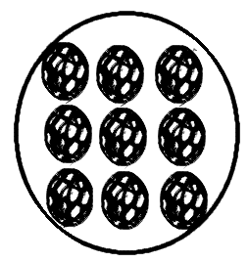**Count and group members in threes.**

1.

There are _____________groups of 3 balls.

There are______________ balls altogether.

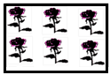

2. There are _____________groups of 3 trees.

There are_____________ trees altogether.

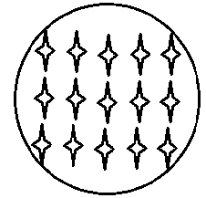

3. There are______________ groups of 3 stars.

There are________________ stars altogether

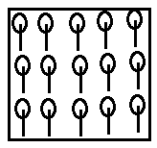4. There are___________ groups of_________ match sticks.

There are ____________matchsticks altogether.

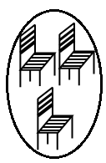

5. There is______________group of _________chairs.

There are ___________ chairs altogether.

C. **GROUPING MEMBERS OF A SET IN FIVES**

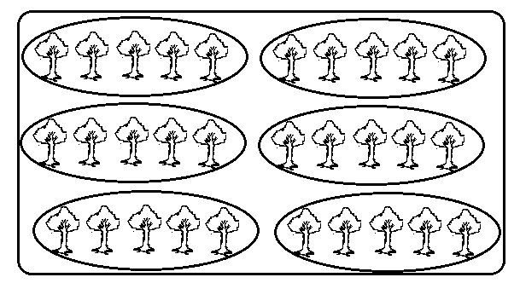 **Examples**

1.

There are **6** groups of **5** matchsticks.

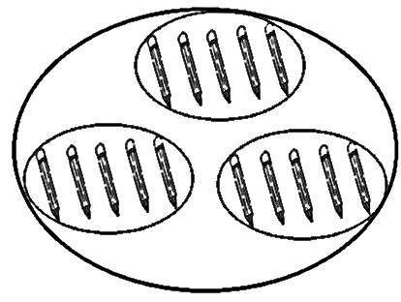There are 30 matchsticks altogether.

2.

There are **3** groups of **5** pencils.

There are **15** pencils altogether.

**Activity**

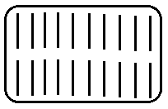1. Count and group members

There are ________________groups of 5 sticks.

There are____________ sticks altogether.

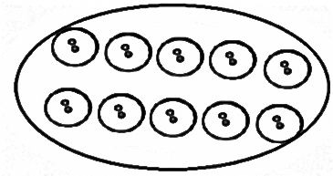

2. There are ___________group of 5 buttons.

There are________ buttons altogether.

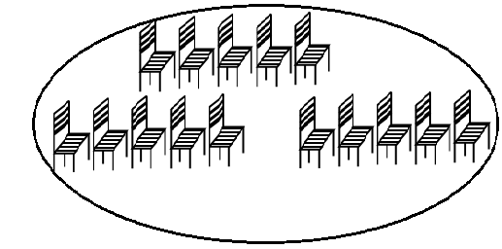3. There are __________group of 5 chairs.

There are __________ chairs altogether.

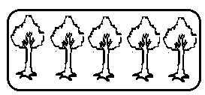

4. There is_______ group of 5 trees.

There are _____ trees altogether.

**MORE ON GROUPING MEMBERS IN A SET.**

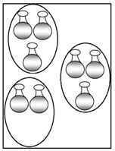 **Example**

1.

*=* ***3*** *groups of______ pots.*

 =_________pots.

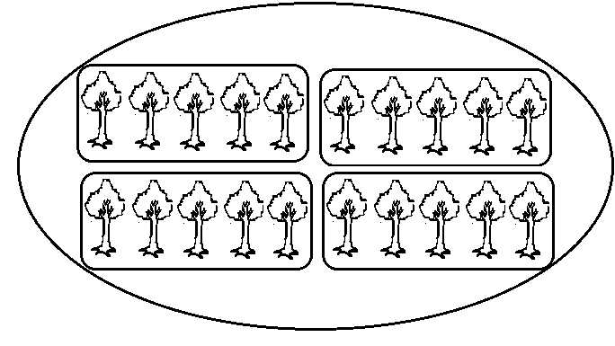

=________groups of______ trees.

2.

=_________trees.

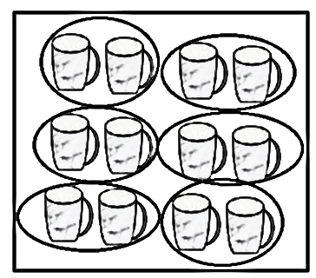

3.

=_______groups of______ cups.

=______cups

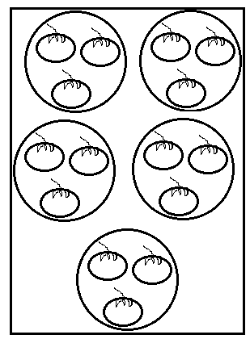

1. =___________groups of __________apples.

=___________apples.

**COMPARING SETS USING “MORE” OR “LESS”**

**Compare the sets below**

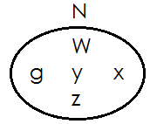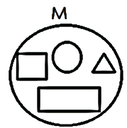**Examples**

1.

Set **M** has **4** members.

Set **N** has **5** members.

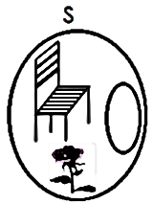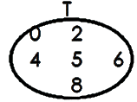Set **N** has more members than set **M**.

2.

Set **T** has **6** members.

Set **S** has **3** members.

Set **S** has less members than set **T**

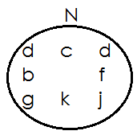 **Activity**

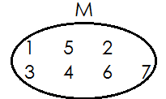1.

1. How many members has set **M**?
2. How many members has set **N**?
3. 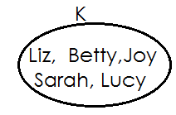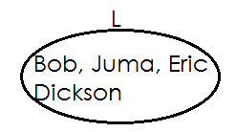Which set has more members?

2.

1. How many members are there in set **K**?
2. How many members are there in set **L**?
3. Which set has more members?

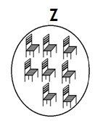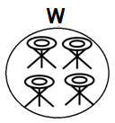3.

(a) How many members has set **Z**?

(b) How many members has set **W**?

(c) Which set has less members?

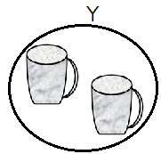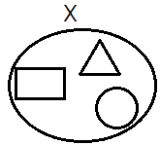4.

1. How many members has set **Y**?
2. How many members has set **X**?
3. Which set has less members?

5. **Q={0,2,4,6,8} R= {1,3,5,7,9,11,13}**

(a) How many members has set **R**?

(b) How many members has set **Q**?

(c) Which set has more members?

**TYPES OF SETS**

**Set symbols**

1. Universal set **Σ**

2. Equal sets

3. Non equal sets

4. Equivalent sets or

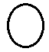5. Non-equivalent sets or

6. Empty set

7. Union of sets

8. Intersection of sets

9. Matching sets or

10. Non-matching sets or

11. Is a member of **Σ**

12. Number of members of n ( )

13. Is not a member of

**EQUAL SETS**

What are equal sets?

 Equal sets are set with the same number and same members

 The set symbol for equal sets is “ ”

The set symbol for non-equal sets is “ ”

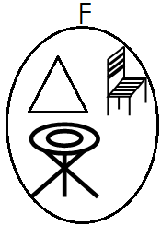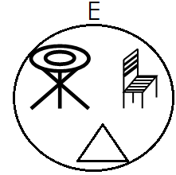 **Examples of equal sets**

1.

Set **E** and set **F** have the same type and number of members

Therefore set **E** and set **F** are equal sets

2. Set A= **{0, 2, 4, 6}** and set B= **{6, 0, 4, 2}**

**Solution**

Set **A** and set **B** have the same type and number of members.

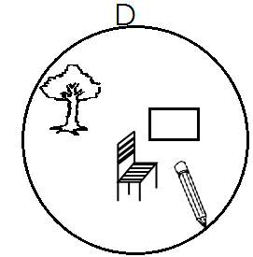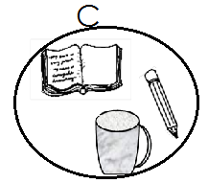 Therefore set **A** is equal to set **B**

3.

Set **C** and set **D** do not have the same type and number of members.

Therefore set **C** is not equal to set **D**

**Activity**

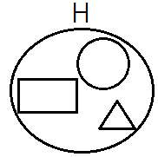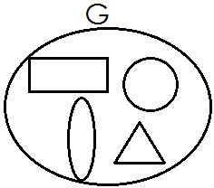Use “**equal**” or “**not equal**”

1.

Set **G** is_____________________ to set H

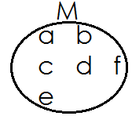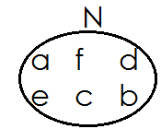2.

Set **M** is _________________to set **N**

3. X={**5,3,7,8,9}** and V**={1,3,5,7,8,9**}

Set **X** is __________________to set **V**

4.

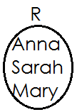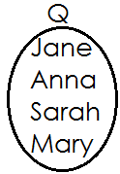Set **Q** is _________________to set **R**

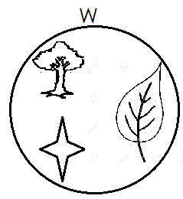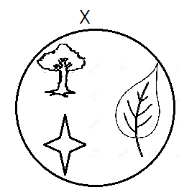

5.

Set W is ___________________to set X

6. Set S= {3, 5, 7} and T= {5, 7, 3}

Set S is _____________________to set T

**Activity two**

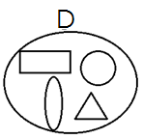 Use or to complete

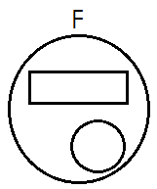1.

Set **D** is_______________ to set **F**

2. **F**= {1, 3, 5, 6, 9} and **Q=** {1, 5, 9}

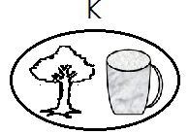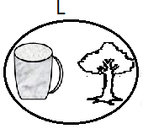 Set **F** is ___________ to set **Q**

3.

Set **K** is_________________ to set **L**

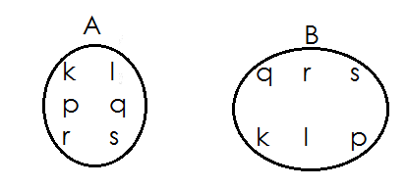

4.

Set **A** is ___________ to set **B**

5. **E**= {**a, b, c, d, e,}** and set **D**= {**b, e, d, a, c**}

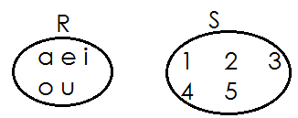 Set **E** is ____________ to set **D**

6.

Set **R** is ____________ to set **S**

**MORE ON EQUAL SETS**

Filing in missing member to make the paired sets equal.

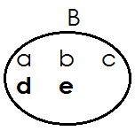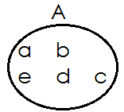 **Examples**

Set **A** and set **B** are now equal.

**Activity**

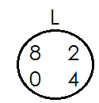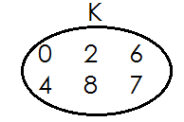 **Make the paired sets equal.**

1.

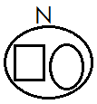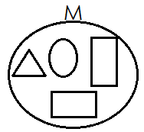

2.

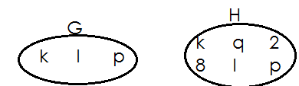3.

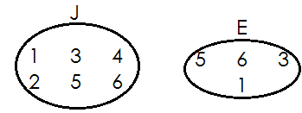4.

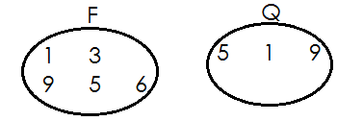

5.

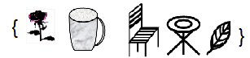

6. A= and B=

**EQUIVALENT SETS**

What are equivalent sets?

Equivalent sets are sets which have the same number of members but maybe of different kind. The symbol for equivalent sets is or or

**Examples of equivalent sets**

1. Set A= {a, d, g, h} and set B= {Annie, Deo, Asha, Ali}

**Solution**

Set A has 4 members and set B has 4 members.

Therefore, set A and set B are equivalent sets.

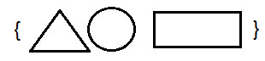

2. Set **P**= and set **Q**=

Set P has **3** members and set **Q** has **3** members.

Therefore, set P is equivalent to set **Q**.

**NON-EQUIVALENT SETS**

 Non-equivalent sets are sets which do not have the same number of members.

**The symbol for non-equivalent sets is** or

**Examples of nonequivalent sets.**

1. Set **A**= {**1, 2, 3, 4**,} and set B = {**a, b, c**}

Set **A**= has **4** members and set B has 3 members

Therefore, set **A** and set **B** Aare non-equivalent sets.

**Or**

Set **A** is not equivalent to set **B**.

**Activity one**

**Use equivalent or not equivalent.**

1. **A**= {**a, b, c**} and **B= {1, 2, 3}**

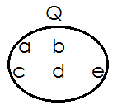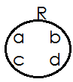 Set **A** is_______________ to set **B**

2.

Set **Q** is_______________ to set **R**

3. Set V= {Anna, Mary, John} and set **X**=

Set **V** is_______________ to set **X**

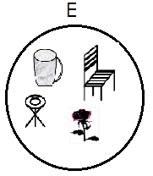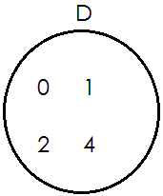

4.

Set **D** is ____________ to set **E**

5. **P**= {**Anna, Mary, Sarah, Joy**} **Q**= {**Anna, Mary, Joy**}

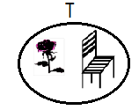 Set **P** is ____________ to set **Q**

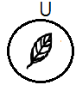6.

Set **T** is ____________ to set **U**

**Activity two**

Use or

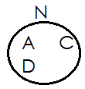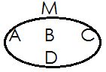

1.

Set **M** is ______________ to set **N**

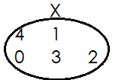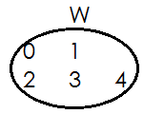

2.

Set **M** is ______________ to set **N**

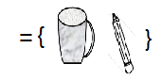

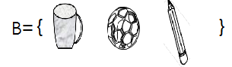3. and C=

**B**______________**C**



4. and

Z_______________Y

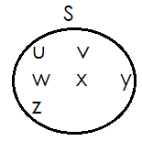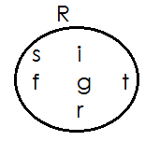

5.

Set **R**_______________ set **S**

6. Set H= {1, 2, 3, 4} and set G=(a, b, c)

H_________________G

**MATCHING AND NON-MATCHING SETS**

 Matching sets are sets with the same number of members.

 The symbol for matching set is or

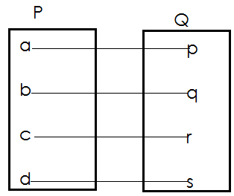 Examples of matching sets

1.

Set **P** has **4** members.

Set **Q** has **4** members.

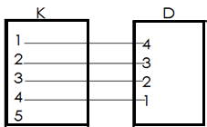Set **P** and set **Q** are matching sets.

2.

Set **K** has **5** members.

Set **D** has **4** members

Set **K** has and d are non-matching sets.

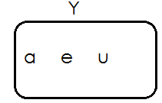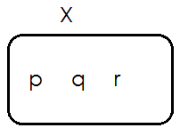 **Activity**

Set **X** has ______________members.

Set **Y** has _____________members.

Set **X** and set y are ___________ sets.

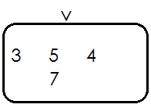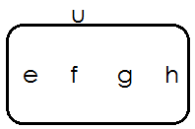2.

Set **U** has ______________members.

Set **V** has _____________members.

Set **U** and set **V** are ________________sets.

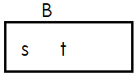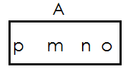3.

Set **U** has ______________members.

Set **V** has _____________members.

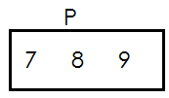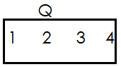Set **A** and set B are _____________ sets.

4.

Set **Q** has ______________members.

Set **P** has _____________members.

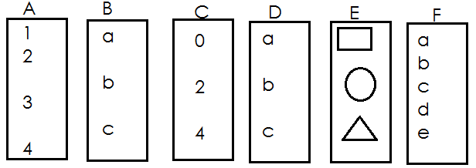Set **Q** and set **P** are_________________ members.

5.

1. set **A** and set **B** are_____________
2. set **A** and set **C** are______________
3. set **A** and set **D** are______________
4. set **C** and set **D** are_______________
5. set **B** and set **D** are_______________
6. set **C** and set **E** are_______________
7. set **A** and set **F** are________________

**EMPTY SETS**

What is an empty set?

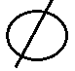An empty set is a set without members. Another name for empty set is null set.

The symbol for empty set is

**Examples of empty sets**

1. Set **K** (pupils in p.3 with 10 legs each)

Set **K** = { } or

2. Set **R** = {our teacher who are less than 3 years of age}

Set **R = { }**

**Activity**

1. Set **X**= (boys in p.3 class with 3 eyes each)

List all members of set x

_____________________________________________________

2. Set **M**= {girls in P.3 who are 90 years old}

List all members of set M.

_______________________________________________________

3. given that t = **{ }.** How many members are in set T?

_______________________________________________________

4. Write empty set or not empty set

(a) A set of parents with 2 babies.

______________________________________

(b) A set of people who have five hands each

__________________________________________

(c) A set of vowels.

___________________________________________

(d) A set of homes with two cars.

_________________________________________

(e) A set of beds with 7 eyes each.

___________________________________________

(f) A set of chair in a house.

____________________________________________

(g) A set of goat with one leg.

____________________________________________

(h) A set of pupils in class

___________________________________________

(i) Three snakes have 6 legs altogether.

_________________________________________________

**LISTING MEMBERS OF A SET**

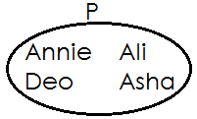 **Examples**

1.

**Set P= {Annie, Deo, Ali, Asha}**

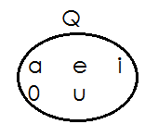

2.

Set **Q** ={**a, e, i, o, u**}

N.B-when listing members of a set, we use curly brackets ie**, {}**

We separate each member from another using a comma

**Activity**

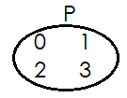List the member of the sets below.

1. Set P = { }

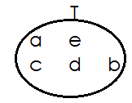

2. Set T= { }

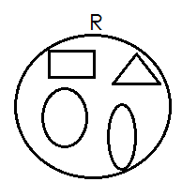

3. Set T= { }

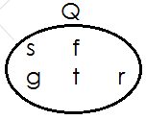

4. Set T= { }

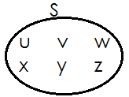

5. Set T= { }

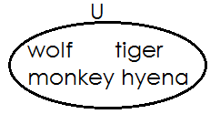

6. Set T= { }

**UNION OF SETS**

A union set is a collection of all members of the given sets without repeating common members.

**N.B**: Common members are written once. The symbol for union sets is “**u**”

**Examples**

1. Given that **W**= **{1, 2, 3}** and set **Z={x, y, z}**

Find **W** **∪** **Z**

**Solution**

**W ∪ Z**={**1, 2, 3, x, y, z}**

2. If set **F**={**c, a, r, e, s**} and G={**c, o, n, e, s**} list down all members of set **F ∪ G**

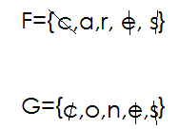 **Solution**

Therefore **FUG ={c, a, r, e, s, o, n}**

**Activity**

1. If set D= **{1, 2, 3, 4, 5} and set C={2,4,6}**

Find **DUC**

2. Given that P= {**a, e, i, o, u}** and Q= {**a, b, c, d}**

What is **PUQ**

3. Set S = {**o, p, q, r, s, t**} and set T= {**m, n, o, p}**

List down all elements of set S **∪** T

4. **M**= {**b, o, y, s**} and N={**c, a, m, b, s}.**

List down all the elements of set **M ∪ N**

5. **A**={**0,2,4,6,8**} and B={**1,2,3,4,5,6,7**}

Find **A ∪ B**

**INTERSECTION OF SETS**

What is an intersection set?

An intersection set is a set of common members.

**Examples**

1. Given that set F={**c, a, r, s}** and G={**c, o, n, e, s**}

Find **F** **∩ G**

**Solution**

F={**c, a, r, s**}

**G**={**c, o, n, e, s**}

**F** **∩** **G** = {**c, s**}

2. **M= {a, b, c, d, e}** and **N= {a, e, I, o, u}. Find M ∩ N**

**Solution**

**M= {a, b, c, d, e}**

**N= {a, e, i, o, u}**

**M ∩ N= {a, e}**

**Activity**

1. If set **A**= **{12, 3, 4, 5}** and set **B= {2, 4, 6, 8}**

Find **A ∩ B**

2. Given that P= **{a, e, i, o, u}**

3. Set w= **{o, p, q, r, s}** and set **R= {m, n, o, p}**

List down all the elements of set **W ∩** **R**

4. **M**= **{b, o, y, s}** and **N={c, a, m, b, s}**

List down all the elements of set **M** **∩ N**

5. IF **y**= {**e, f, g, h**} and X={**r, s, t, u, v**}

Find **Y** **∩** **X**

**FINDING NUMBER OF MEMBERS IN A SET USING SYMBOL** “n”

**Examples**

1. If **K**= **{a, b, c, d}** find **n{k}**

**K**= **{a, b, c, d}**

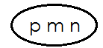 Therefore **n(k)=4**

2. Given that set **R =**

How many members are in set R?

R= {p, m, n}

n(R)=3

3. Set **A**= **{d, i, g}** and set **B= {d, o, n, e}**

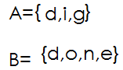 How many embers are in set **A ∪ B?**

**A ∩ B= {d}**

Therefore **n{A ∩ B} = 1**

4. Set **H**= **{d, o, w, n}** and **G={d, a, w, n}**

**H** **∪ G**= **{d, o, w, n, a}**

Therefore **n{H ∪ G}=5**

**Activity**

1. If **Z**= {**a, e, I, o, u**}. Find **n{z}**

2. Given that **x= {1, 2, 3, 4, 0}.** Find **n{x}**

3. R**={1,2,3,4,5}** and **s={2,4,6,8}.**find **n**{**R ∩ S**}

4. W= **{o, p, q, r, s}** and **R= {m, n, o, p}.** Find n{**W ∩ R**}

5. given that **V**={**s, t, r, p}** and **Z={s, t, r, e, a, m**} find **n{V ∪ Z**}

6. If **C**= {**1, 2, 3, 4, 5, 6**} and **D= {0, 3, 6, 9}**

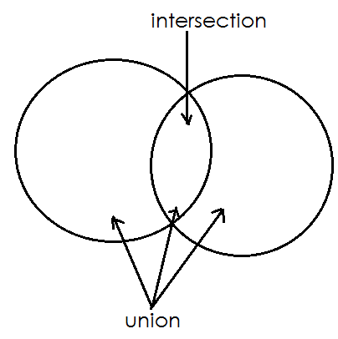 **A VENN DIAGRAM**

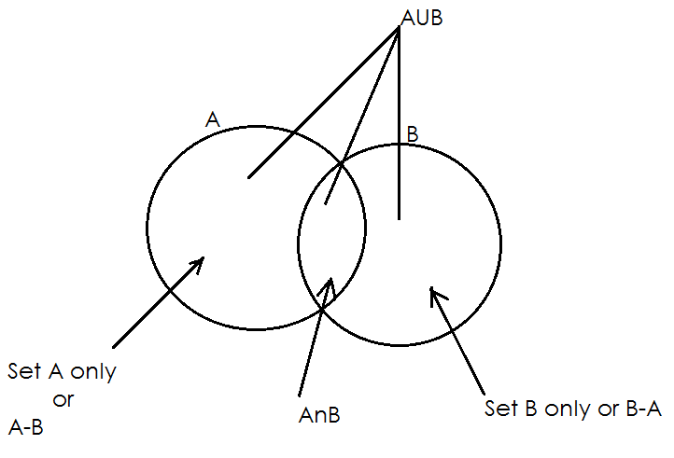**D**i**fferent parts of a Venn diagram**

**SHADING REGIONS ON A VENN DIAGRAM**

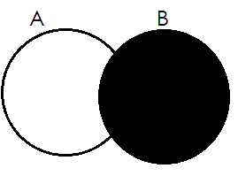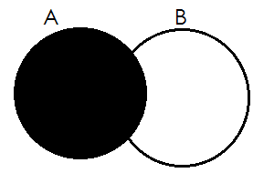1. Set A 2. Set B

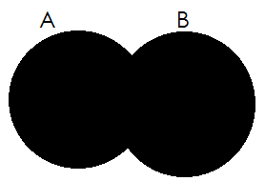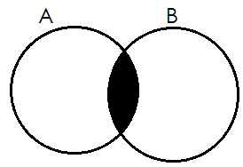3. A∩B 4. AUB

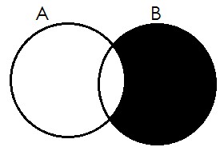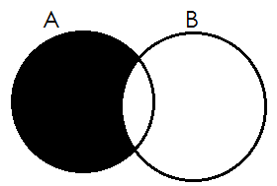5. A only 6. B only

**Activity**

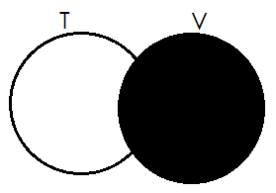**Describe the shaded regions of the Venn diagram below.**

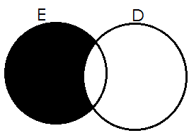

1. 2.

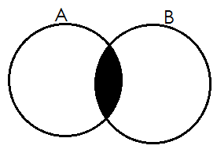____________________ ___________________

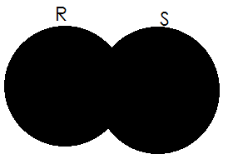3. 4.

________________ ____________________

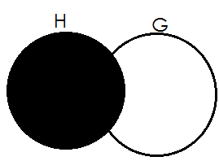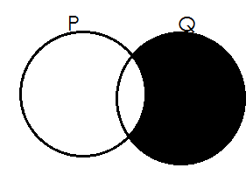

5. 6.

____________________ _______________________

**REPRESENTING MEMBERS /ELEMENTS ON A VENN DIAGRAM**

**Examples**

1. Given that A= {**a, b, c, d}** and B= {**d, a, l, f, e**} show the two sets on a Venn diagram

**A= {a, b, c, d}**

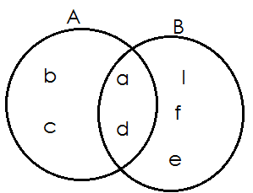 **B= {d, a, l, f, e}**

**Activity**

**Represent the sets below on the Venn diagram**

1. **P= {1, 2, 3, 4, 5,}**

**Q= {0, 2, 4, 6, 8}**

2. **N= {a, e, i, o, u}**

**M= {m, a, n, g, o**}

3. **A={dog, cow, pig, sheep, cat}**

**B= {pig, fig, log, leg, dog}**

4. **K= {5, 10, 15, 20, 25}**

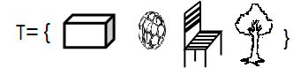 **L= {3, 5, 7, 9, 12, 15}**

5.

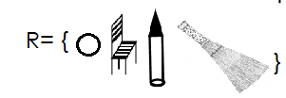

6. **C= {1, 2, 3, 4, 5,}**

**D= {0, 2, 4, 6, 8}**

7. **G= {10, 20, 30, 40}**

**H= {5, 10, 15}**

**USING VENN DIAGRAMS TO SOLVE SET PROBLEMS**

**Example 1**

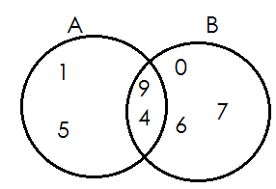 **Study the Venn diagram and answer the questions that follow**.

(a) List down all members of stet **A**

{**1, 5, 4, 9**}

(b) List down all elements of set **B**.

{**0, 6, 7, 4, 9**}

(c) Write down all members of **A** **∪ B**

**{1, 5, 9, 4, 0, 6, 7}**

(d) Find n {**A** **∩** **B**}

**N {A ∩ B}= {4,9}**

Therefore n{**A** **∪** **B}=2**

(e) Find **n{A-B}**

**n{A-B}={1,5}**

**Therefore n{A-B} =2**

**Example 2**

Given that set **P= {a, b, c, d}** and set **M= {d, e, f}**

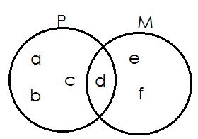a. Represent set **P** and **K** on the Venn diagram below.

b. Find

(i) **P ∩ M**

**P ∩ M** = {d}

(ii) **P ∪ M**

P **∪** M= {a, b, c, d, e, f}

(iii) n(P)

n(P) = {a, b, c, d}

**Therefore n(P)=4**

(iv) n(M) = {d, e, f}

n(M) = 3

(v) n{M-P}

n{M-P} = {e, f}

Therefore n{M-P} = 2

(vi) n(P-M)

n(P-M) = {a, b, c}

Therefore n(P-M) = 3

**Activity**

1. Study the Venn diagram below and answer the questions

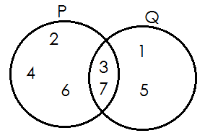

(a) List down all elements of set **P**

(b) Find P **∪** Q

(c) How many members are in set **P ∩ Q.**

(d) What is n(Q)?

2.If set M= {1, 2, 3, 4, 5} and set N= {0, 2, 4}

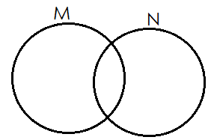(a) Fill in the Venn diagram below using set M and N.

(b) Find n(M)

(c) How many elements are in set N?

(d) Find:

(i) **n (M ∩ N)**

(ii) **n (M ∪ N)**

3. Given that set A**= {a, e, i, o, u}** and set B= **{a, b, c, d}**

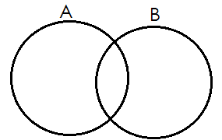(a) Fill in the Venn diagram below using set A and set B

(b) How many members are in set A?

(c) Find

(i) **n(B)**

(ii) **A ∩ B**

(iii) **n(A ∪ B)**

(iv) **n(A)**

**THEME: NUMERACY**

**TOPIC: WHOLE NUMBERS**

**SUB-TOPIC: THOUSANDS, HUNDREDS, TENS AND ONES**

**PLACE VALUES OF WHOLE NUMBERS**

**Qn. What is a place value?**

* A place value is the position of a digit in a number.

Finding place values of numbers

**Examples**

1. Write the place value of each digit in the number

**TH-thousands**

**H-hundreds**

**T-tens**

**O-ones**

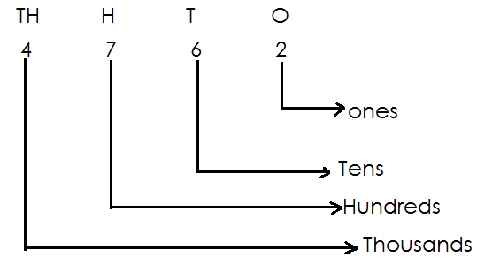

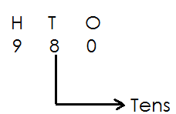2. Find the place value of 8 in 980

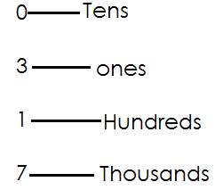3. Write the place value of each digit in 1703?

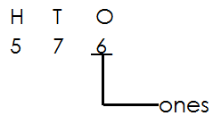4. Find the place value of the underlined digit in the number

**Activity**

1. Write the place value of each digit in

(a) **4073**  (c) **9467** (b) **871** (d) **59**

2. Find the place value of the underlined digits in the number

(a) **9321** (b) **3204** (c) **6821** (d) **5297**

3. Write the place value of the underlined digits in

(a) **4094** (b) **681** (c) **9764** (d) **5723**

4. What is the place value of **2** in **8026**?

5. Find the place value of **6** in **1640**

6. What is the place value of **9** in **9000**?

**VALUES OF WHOLE NUMBERS**

**A value** is the amount a digit holds in a number

**Examples**

1. Write the value of each digit in **6932**.

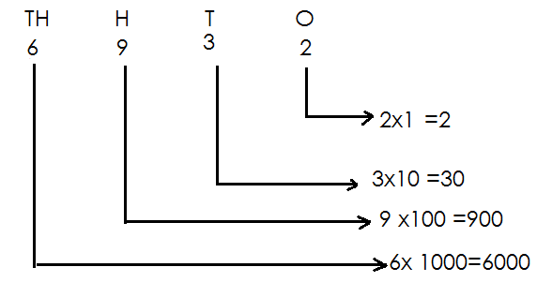 **Solution**

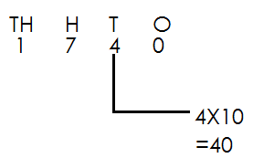2. Find the value of 4 in 17 40

**Activity**

1. Find the value of each digit in

(a) **9476**

(b) **524**

(c) **1725**

2. What is the value of **7** in **7185**?

3. Find the value of the underlined digits

(a) **6931**  (c) **7320** (b) **8321** (d) **5631**

4. Calculate the value of 6 in the number

(a) **6800**

(b) **4361**

(c) **9674**

**ADDITION OF VALUES OF NUMBERS**

Examples

1. 7 tens + 5 ones=

(7x10) + (5x1)

70 + 5

75

2. **2** hundreds + **7** tens + **3** ones

(2x100)+ (7x10) + (3x1)

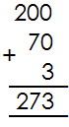 200 + 70 +3

**Activity**

Add the value of the following numbers

1. **2** tens + **5** ones=

2. **5** hundreds + **4** tens=

3. **6** thousands + **6** hundreds + **7** tens + **3** ones =

4. **8** thousands + **9** hundred =

5. **7** thousands + **4** hundreds+ **7** ones=

6. **1** thousand + **3** tens + **4** ones=_______________

**SUBTRACTING VALUES OF NUMBERS**

**Examples**

1. **5** tens- **3** tens=

(5x10)- (3x10)

=50-30

=20

2. **5** hundreds-**6** tens=

(5x100) – (6x10)

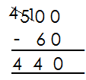 500-60

**Activity**

**workout the following**

1. **8** thousands - **7** thousands =

2. **9** tens - **2** tens =

3. **4** tens - **1** ten =

4. **3** hundreds - **5** tens =___________

5. **6** hundreds - **5** tens =

6. **5** thousands - **2** thousands =

7. **7** hundreds - **8** tens =

**MULTIPLYING VALUES OF NUMBERS**

**Examples**

1. **4** tens x **6** ones=

(4x10) x (6x1)

40x6

**= 240**

2. **6** hundreds x **2** ones =

(6x100) x (2x1)

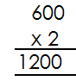 600 x 2

3. **1** thousand x **3** ones =

(1x1000) x 3 x1

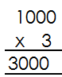1000x3

**Activity**

1. **2** tens x **2** ones=____________

2. **8** tens x **4** =__________________

3. **4** hundreds x **4** ones =_________

4. **5** thousands x **3** ones =__________

5. **2** hundreds x **6** ones =___________

6. **7** thousands x **2** ones =_____________

**EXPANDING NUMBERS**

**EXPANDING NUMBERS USING VALUES**

**Examples**

1. Expand 312 using values

(3X100) + (1X10) + (2X1)

300+10+2

2. Expand **5146** using values

(5x1000) + (1x100) + (4x10) + (6x1)

5000+100+40+6

**Activity**

Expand the following numbers using values

1. 275

2. 7856

3. 1002

4. 5471

5. 8909

6. 58

7. 560

8. 317

9. 28

10. 4846

**EXPANDING NUMBERS USING PLACE VALUES**

**Examples**

1. 586=5 hundreds + 8 tens + 6 0nes

(5x100) + (8x10) + (6x1)

2. 6135=6 thousands + 1hundred+ 3 tens + 5 ones

(6x1000) + (1x100) + (3x10) + (5x1)

**Activity**

Expand the following numbers using place values

1. 792

2. 46

3. 1381

4. 5092

5. 1234

**FINDING THE EXPANDED NUMBERS**

**Examples**

1. Which number is shown by expansion?

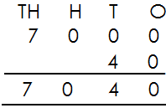 7000+40+8

2. What number has been expanded to give?

(4x1000) + (7x100) + (5x10) + (6x1)

4000 + 700 + 50 + 6

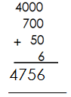

**Activity**

**What number has been expanded?**

1. 6000+60+6

2. (2x100) + (3x10) + (8x1)

3. 7000+300+50+4

4. 4000+500+60+2

5. (9x1000) + (2x100) + (7x10) + (5x1)

6. 700+70+0

7. (6x10) + (2x1)

**WRITING NUMBERS SHOWN ON THE ABACUSES**

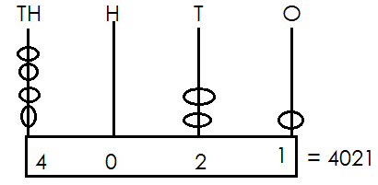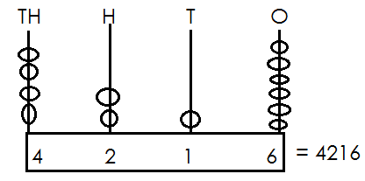 Examples

1. 2.

**Activity**

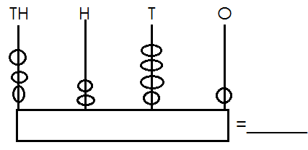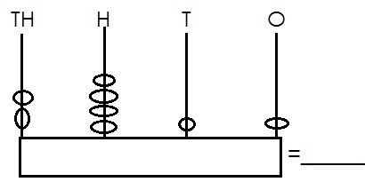Write the number shown on the abacuses.

1. 5.

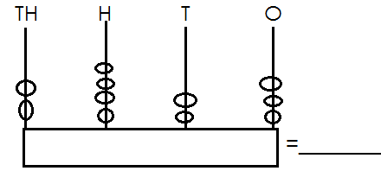

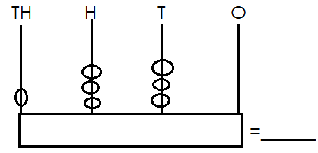

2. 6.

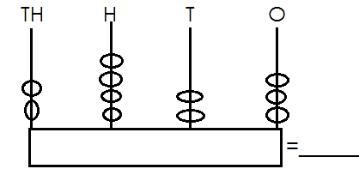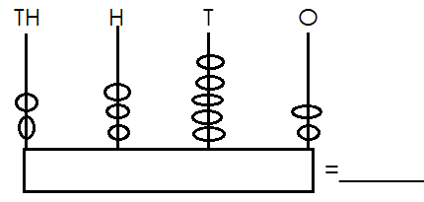3. 7.

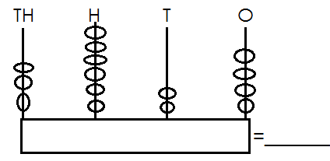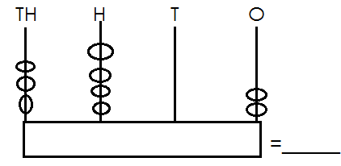

4. 8.

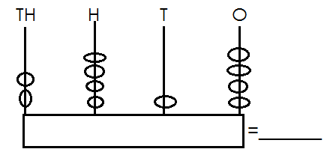

9.

**Drawing abacuses for the number**

**Examples**

1. 1254 = 2. 3052 =

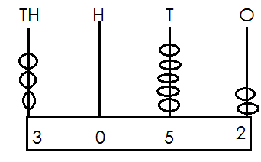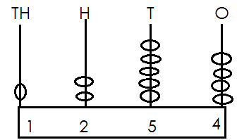

**Activity**

**Show the following numbers on the abacuses**

1. 1306 6. 6289

2. 9700 7. 8447

3. 7924 8. 6024

4. 8143 9. 8142

5. 5677 10. 5677

**FILLING IN THOUSANDS, HUNDREDS, TENS AND ONES.**

**Examples**

1. **9** thousands **4** hundreds **6** tens **0** ones

=9460

2. 2478= **2** thousands **4** hundreds **7** tens **8** ones

**Activity**

**Fill in thousands hundreds tens and ones**

1. **7** thousands **2** hundreds **3** tens **6** ones =_______________

2. **8** thousands/hundreds **6** tens **5** ones =_____________

3. **6** thousands **7** hundreds **1** ten **2** ones =______________

4. **1** thousand **0** hundreds **0** tens **4** ones =_____________

5. **2** thousands **0** hundreds **2** tens **0** ones =____________

6. **7214** =______ thousands _____hundreds ____ tens ____ones

7. **696** =______ thousands _____hundreds ____tens ____ones

8. **5218** =______ thousands _____hundreds ____tens ____ones

9. **2020** =______ thousands _____hundreds ____tens ____ones

10. **1995** =______ thousands _____hundreds ____tens ____ones

**MORE ON WRITING THOUSANDS, HUNDREDS, TENS AND ONES**

**Examples**

1. **4** thousands **3** hundreds **2** tens **5** ones = **4325**

2. **6** thousands **5** hundreds **2** tens **0** ones = **6520**

3. **2875** = **2** thousands **8** hundreds **7** tens **5** ones

4. **7029**= **7** thousands **0** hundreds **2** tens **9**ones

**Activity**

**Write thousands, hundreds, tens and ones**

1. ______ thousands _____hundreds ____tens ____ones=1934

2. ______ thousands _____hundreds ____tens ____ones=7453

3. ______ thousands _____hundreds ____tens ____ones= 3200

4. ______ thousands _____hundreds ____tens ____ones= 1731

5. ______ thousands _____hundreds ____ tens ____ones=5527

6. ______= **1** thousand **4** hundreds **3** tens **7** ones

7. ______= **0** thousand **9** hundreds **4** tens **8** ones

8. ______= **4** thousand **2** hundreds **5** tens **2** ones

9. ______= **7** thousand **7** hundreds **2** tens **0** ones

10. ______= **8** thousand **0** hundreds **0** tens **0** ones

**DRAWING BUNDLES OF THOUSANDS, HUNDREDS, TENS AND ONES**

**Examples**

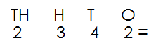1. Draw bundles to represent 2342

|  |  |  |  |
| --- | --- | --- | --- |
| Th | H | T | O |
| 2 | 3 | 4 | 2 |
|  |  |  |  |

2. Draw bundles to represent 215

|  |  |  |
| --- | --- | --- |
| H | T | O |
| 2 | 1 | 5 |
|  |  |  |

3. Draw bundles to represent 39

|  |  |
| --- | --- |
| T | O |
| 3 | 9 |
|  |  |

**Activity**

Draw bundles to represent

1. 13

2. 47

3. 123

4. 325

5. 1248

6. 246

7. 2290

8. 23

9. 1147

**WRITING NUMBERS IN WORDS**

**Note**: When reading numbers in words, read tens and ones together.

**Examples**

1. Write **48** in words

**48**= forty eight

2. Write **219** in words

**219** = two hundred nineteen

**Activity**

Write the following numbers in words

1. 14 6. 718

2. 35 7. 199

3. 96 8. 528

4. 49 9. 500

5. 421 10. 672

**WRITING NUMBER WORDS IN FIGURES**

**Examples**

1. Write ninety six in figures

**Ninety six =96**

2. Write two hundred twelve in figure

Two hundred=**200**

Twelve= +**12**

**Two hundred twelve=212**

3. Write eight hundred fifty in figures

Two hundred= **200**

Fifty = +**50**

Two hundred fifty= **250**

**Activity**

Write number word in figures

1. three hundred thirty-four.

2. ninety-five

3. seven hundred fifty-three

4. eight hundred thirty-nine

5. seventy-three

6. four hundred sixty-seven

7. seven hundred forty-nine

8. eight hundred one

9. seventy-two

10. eleven

**WRITING WHOLE NUMBER IN WORD**

(Thousands, hundreds, tens and ones)

**Note**: when writing numbers in words read tens and one together

**Examples**

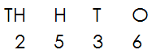1. Write **2536** in words

Two thousand five hundred thirty-six

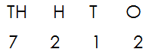2. Write **7212** in words

Seven thousand two hundred twelve

3. Write **310**4 in words

Three thousand one hundred four.

**Activity**

Write the following in words

1. 4718 6. 2538

2. 8000 7. 1840

3. 7049 8. 2116

4. 5399 9. 4009

5. 6411 10. 5234

**Write number words in figures**

**Examples**

1. Write two thousand five hundred thirty-six in figure

Two thousand= 2000

Five hundred= + 500

Thirty-six = 36

2536__

2. Write seven thousand two hundred twelve in figures

Seven thousand = 7000

Two hundred = 200

Twelve = 12

7212

**Activity**

1. One thousand, six hundred thirty-six

2. One thousand, nine hundred fifteen.

3. Two thousand, six hundred four.

4. Three thousand four hundred fifty.

5. Nine thousand two hundred eleven.

6. Eight thousand seven hundred twenty.

7. Three thousand one hundred eighty-one

8. Five thousand two hundred nineteen.

9. One thousand

10. Three thousand six hundred seventy-nine.

**NUMERALS**

A numeral is a symbol that represents a number.

**Example**

|  |  |
| --- | --- |
| **Number** | **Numeral** |
|  | 4 |

**Types of numerals**

1. Hindu Arabic numerals

2. Roman numerals

**Hindu Arabic numerals**

**Examples of Hindu Arabic numerals**

0,1,2,3,4,5,6,7,8,9……………

**ROMAN NUMERALS**

These are numerals that were introduced by the Asians.

Types of Roman Numerals

(a) Major roman numerals

|  |  |
| --- | --- |
| I  V  X  L  C | 1  5  10  50  100 |

(b) Roman numerals got by repeating I or x

(i) Repeating.

2= I+I

=II

3=I + I +I

=III

(ii) By repeating X

20=X + X

=XX

30=X + X +X

=XXX

(c) **Roman numerals got by adding I, III, to v**

6=5+1

= VI

7= 5+2

VII

(d) **Roman numerals got by adding, I, ii, iii to x**

11= 10+1

**= XI**

12= 10+2

=X II

**= XII**

13=10+3

**XIII**

(e) **Roman numerals got by subtracting 1 from 5**

4=5-1

**VI**

**Roman numerals got by subtracting**

1 from 10

9=10-9

**= IX**

(g) **Roman numerals got by subtracting**

10 from 50

40=50-10

**= XL**

**ROMAN NUMERALS FROM 1-50**

|  |  |
| --- | --- |
| 1 | I |
| 2 | II |
| 3 | III |
| 4 | IV |
| 5 | V |
| 6 | VI |
| 7 | VII |
| 8 | VIII |
| 9 | IX |
| 10 | X |
| 11 | XI |
| 12 | XII |
| 13 | XIII |
| 14 | XIV |
| 15 | XV |
| 16 | XVI |
| 17 | XVII |
| 18 | XVIII |
| 19 | XIX |
| 20 | XX |
| 21 | XXI |
| 22 | XXII |
| 23 | XXIII |
| 24 | XXIV |
| 25 | XXV |
| 26 | XVI |
| 27 | XVII |
| 28 | XVIII |
| 29 | XXIX |
| 30 | XXX |
| 31 | XXXI |
| 32 | XXXII |
| 33 | XXXIII |
| 34 | XXXIV |
| 35 | XXXV |
| 36 | XXXVI |
| 37 | XXXVII |
| 38 | XXXVIII |
| 39 | XXXIX |
| 40 | XL |
| 41 | XLI |
| 42 | XLII |
| 43 | XLIII |
| 44 | XLIV |
| 45 | XLV |
| 46 | XLVI |
| 47 | XLVII |
| 48 | CLVIII |
| 49 | XLIX |
| 50 | L |

**Changing Hindu Arabic to roman numerals**

**Examples**

1. Change **7** to Hindu Arabic numerals

7= 5+2

= VII

7= VII

2. Tony is **14** years old. Express his years in roman numerals.

14 = 10 + 4

14 = XIV

**Activity**

1. Change **9** to Roman numerals

2. Express **26** in Roman numerals

3. Change **48** to Roman numerals

4. There **7** days in a week. Express the days in Roman numerals.

5. John has **29** cows. How many cows does he have in Roman numerals?

6. Write **15** in Roman numerals.

7. Daniel weighs **42**kg. Express his weight in Roman numerals.

8. Change the following to Roman numerals

(a) **8** (b) **15** (c) **24**  (d) **39**  (e) **12** (f) **28**

**CHANGING ROMAN NUMERALS TO HINDU ARABIC NUMERALS**

**Examples**

**Note:** expand and change to Hindu Arabic numerals

XIX

|  |  |
| --- | --- |
| X | IX |
| 10 | 9 |

= 10+9

= 19

2. Change IV to Hindu Arabic numerals

IV = 5 - 1

= 4

3. Jane is XXVI years old. Write her age in Hindu Arabic numerals

XXVI

|  |  |
| --- | --- |
| XX | VI |
| 20 | 6 |

= 20 + 6

= 26years

**Activity**

1. Change the following to Hindu Arabic numerals

(a) **XXII** (b) **XXXV** (c) **VII** (d) **XLIII**

2. A boy walked a distance of VIII metres. Express the distance in Hindu- Arabic numerals.

3. Mukisa weighs xix kilograms. Find his weight in Hindu-Arabic numerals.

4. An adult person has **XXXII** teeth. Express the teeth in Hindu -Arabic numerals.

**MATCHING ROMAN NUMERALS TO HINDU -ARABIC**

**Examples**

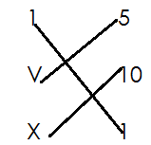 Match Roman numerals to Hindu –Arabic

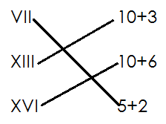Study the numbers and match

**Activity**

**Match roman numerals to Hindu - Arabic**

1. IV 9

VIII 19

IX 4

XIV 14

XXII 22

XIX 8

2. VI 10+8

XI 20+5

XVI 5+1

XVIII 10+6

XIV 10+1

XXV 20+4

**OPERATIONS ON WHOLE NUMBERS**

**Addition of number without regrouping/ carrying**

**Examples**

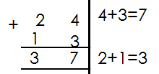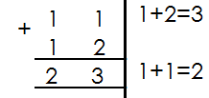1. Add 11+ 12 2. Add 24+13

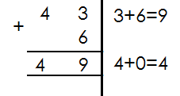3. Add:

**Activity**

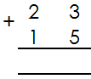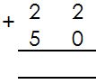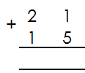 **Add the following**

1. 2. 3.

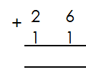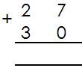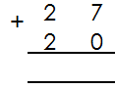

4. 5. 6.

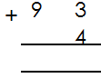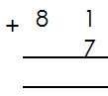

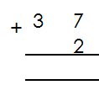8. 9.

7.

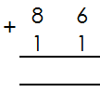

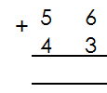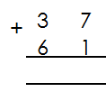

10. 11. 12.

**WORD PROBLEMS INVOLVING ADDITION WITHOUT REGROUPING**

**Examples**

1. Ashaba had 32 mangoes. She picked 17 more mangoes. How many mangoes did she have altogether?

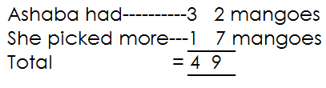

2. Wamanga made 24 pancakes. His friend gave him 30 more pancakes. How many pancakes did he have?

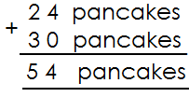

**Activity**

1. Okot had **55** cows. His brother had **21** cows. How many cows did the two brothers have?

2. Ssalongo had **42** goats. Nalongo had **52** goats. How many goats did they have altogether?

3. Epeju had **14** goats. Nalumanssi had **72** goats. How many goats do they have altogether?

4. Agnes collected **43** mangoes and **12** oranges. How many fruits did she collect altogether?

5. Mabale had **38** eggs. Nambozo had **41** eggs. How many eggs did they have altogether?

6. Opio made **33** pots. His wife made **24** more pots. How many pots did they make altogether?

7. Acen picked **40** guavas and A can picked **7**. How many guavas did they pick altogether?

**MORE ON ADDITION OF NUMBERS WITHOUT REGROUPING**

**Examples**

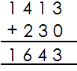1. Add: 1413+230

2. Add: 542 + 22

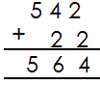

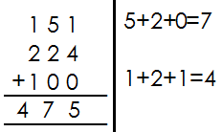3. Add: 151+224+100

**Activity**

**Read and workout**

1. 1230+110

2. 2141+1402+5223

3. 11+130+340

4. 2143+321

5. 1582+6314

6. 246+422

7. 4264+1101+3413

8. 3492+307

**MORE ON WORD PROBLEMS INVOLVING ADDITION OF NUMBERS WITHOUT REGROUPING.**

**Examples**

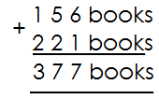1. James had **156** books. He got **221** more. How many books did he have altogether?

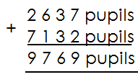2. Our school had **2637** pupils last year. It received **7132** pupils this year. How many pupils are in the school now?

**Activity**

1. Find the sum of **32453** and **41532**

2. Find the sum of sh **56321** and sh **23535**

3. Musa earns sh **63042** and Juliet earns **32416**. How much do both earn?

4. A district education officer gave **25204** books to schools in January and **30242** books in March. How many books were given out altogether?

5. A school A got **53107** books and school B got **41632** books. What is the total number of books which was given to the two school?

6. One parent donated sh **42463** to the school and another parent donated sh **43120**. What was the total amount of money donated to the school?

7. Add **42017** and **54301**.

**ADDITION OF NUMBERS INVOLVING REGROUPING**

**Examples**

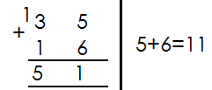 **Add the following**

1.

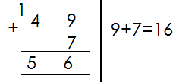2.

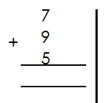3. 7+9+5=

**Activity**

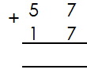 **Add the following numbers**

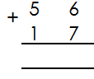

1. 8+9+8=

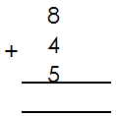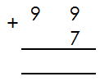

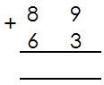

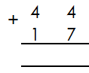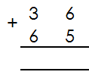

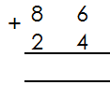

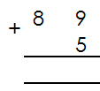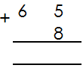

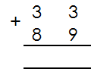

**MORE ON ADDITION OF NUMBERS INVOLVING REGROUPING**

**Examples**

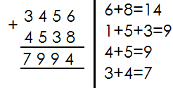1. Add: 3456+4538

2. Add: 323 + 24 6 + 453

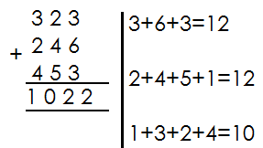

3. Add: 345 + 96

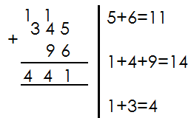

**Activity**

**Add the following numbers**

1. 1684+ 1469 =

2. 267+69 =

3. 5834+2487 =

4. 899+27 =

5. 1574+188 =

6. 2853 +987 =

7. 1876+2547 =

8. 582+49 =

**WORD PROBLEMS INVOLVING ADDITION OF NUMBERS WITH REGROUPING**

**Example**

1. Juma had **4156** books. He got **786** more books. How many books did he have altogether?

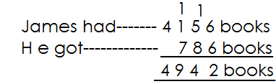 **Solution**

**Activity**

**Read and add**

1. Find the sum of **496** and **174**

2. What is the sum of **24, 37** and **425**?

3. What is **4798** plus **3362**?

4. A train carried **120** children **236** men and **325** women. How many people did it carry altogether?

5. A farmer has **494** cows and 847 sheep. How many animals does he have altogether?

6. Our school had **639** pupils last year. It received **97** more pupils this year. How many pupils are in the school altogether?

7. A village had **4837** men and **7246** girls. How many people are in the village altogether?

8. Agnes had **790** bags of millet Joan had **1724** bags and rose had **365** bags. How many bags do they have altogether?

**SUBTRACTION OF NUMBERS WITHOUT REGROUPING**

**Examples**

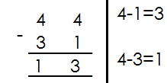1. Subtract:

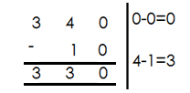2. Subtract:

**Activity**

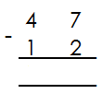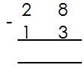 Subtract the following numbers.

1. 4. 7. 999 - 89

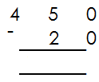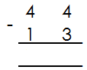2. 5. 8. 72 - 30

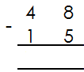 9. 424 - 14

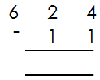3. 6.

10. 1324 - 112

**WORD PROBLEMS INVOLVING SUBTRACTION OF NUMBERS WITHOUT REGROUPING**

**Examples**

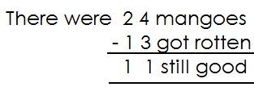1. There were **24** mangoes in a box **13** of them got rotten. How many mangoes are still good?

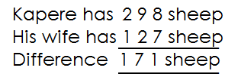2. Kapere has **298** sheep. His wife has **121** sheep. What is the difference between their number of sheep?

**Activity**

**Read and subtract**

1. What is the difference between **94** and **61**?

2. Find the difference between sh. **970** and sh. **250**?

3. Sandra had **65** cows. She sold off **35** cows. How many cows were left?

4. There are **186** cars in a hire. **80** of them were red in colour. How many cars were not red in colour?

5. Subtract**474** from **997**.

6. Subtract **57**kg from **689**kg.

7. Mukasa bought **780** crates of soda. He sold **480** crates. How many crates remained?

8. A farmer packed **738** litres of milk 615 liters were sold. How many litres were not sold?

**MORE ON SUBTRACTION OF NUMBERS WITHOUT REGROUPING**

**Examples**

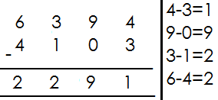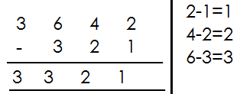 Subtract:

1. 2. Workout:

**Activity**

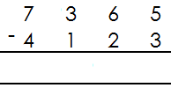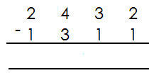 **Work out the following**

1. 5.

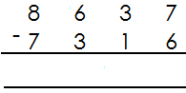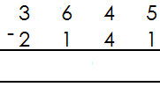

2. 6.

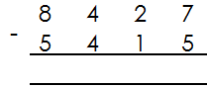

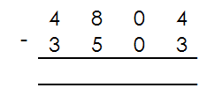3. 7.

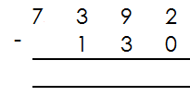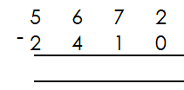4. 8.

**MORE ON WORD PROBLEMS**

**Examples**

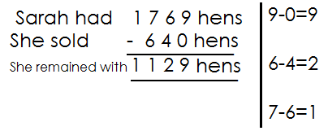1. Sarah had **1769** hens. She sold **460** hens. How many hens remained?

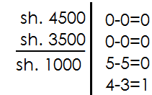2. Find the difference between sh. 4500 and sh. 3500.

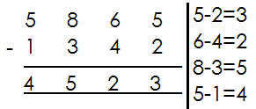3. Subtract: 5865 - 1342

**Activity**

**Read and workout**

1. Mugga had **1667** chicks. He sold off **441** chicks. How many chicks did he remain with?

2. What is the difference between **8456** and **3214**?

3. In a village of **8652** people, **6231** were females. How many males are there?

4. A teacher had **5720** pencils and she gave **3220** pencils to the pupils. How many pencils did she remain with?

5. There were **9729** eggs in the basket and **2315** of them got broken. How many eggs were left?

6. A carpenter made **2964** desks and he sold **350** desks. How many desks were left?

7. Subtract **456** from **9697**.

8. Workout the difference between **2440** years and **2020** years.

**SUBTRACTION OF NUMBERS WITH REGROUPING**

**Examples**

1. Subtract: 91-53

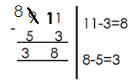 **Solution**

2. Subtract: 124-35

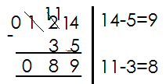 **Solution**

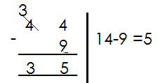3. Subtract 44-9

**Activity**

Subtract the following numbers

1. 94-6 6. 897-29

2. 82-7 7. 568-278

3. 95-17 8. 935-277

4. 84-39 9. 629-79

5. 413-144 10. 811-245

**WORDS PROBLEMS INVOLVING SUBTRACTION OF NUMBERS WITH REGROUPING**

**Key words**

- Difference - remove

- Takeaway - less

- Remain - subtract

- Reduce - minus

- Left - gave away

**Examples**

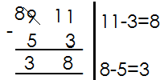1. Subtract 53 from 91

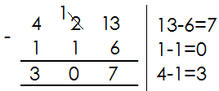2. What is left when I remove 116 from 423?

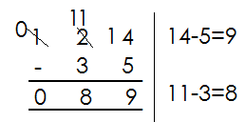3. Remove 35 from 124

**Activity**

**Read and subtract**

1. What is the difference between **653** and **175**?

2. Take away **87** from **199**.

3. Find the difference between **376** and **297**.

4. A boy did **400** numbers and failed **130** numbers. How many numbers did he get correct?

5. By how much is **851kg** greater than **364kg**?

6. Kabundi had sh. **500**. He gave away some to Andrew leaving sh. **250.** How much money did he give away?

7. Remove **93** from **231.**

8. Mwanje had **413** books. He removed **175** of them and gave them to Mr. Lindo. How many remained?

**MORE ON SUBTRACTION INVOLVING REGROUPING**

**Examples**

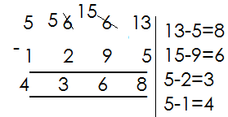1. Subtract: **5663** - **1295**

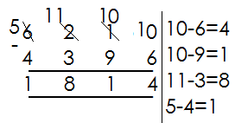2. Subtract: **6210** - **4396**

**Activity**

**Subtract the following numbers**

1. 3664 - 1395

2. 9564 - 5362

3. 9058 - 3749

4. 7683 - 2799

5. 9500 - 5769

6. 3541 - 1021

8. 8504 - 7694

9. 8330 - 6879

10. 6210 – 4396

**WORD PROBLEMS INVOLVING SUBTRACTION OF NUMBERS WITH REGROUPING**

**Examples**

1. Reduce **1776** by **469**

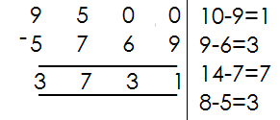2. What number is **5769** less than **9500**?

3. Safina bought 4750 bottles of soda. She sold 1965 bottles. How many were left?

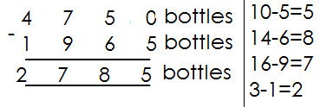 **Solution**

**Activity**

**Read and workout**

1. Subtract **3248** from **7368**.

2. Reduce **4232** by **2186**.

3. What number is **4397** less than **5642**?

4. A farmer had **4075** litres of milk **3986** litres were sold. How many litres remained?

5. Sudhir imported **3568** bicycles. He gave away **1698** bicycles to other traders. How many bicycles did he remain with?

6. Betty was born in **1997**. How old was she in **2005**?

7. In a class of **1205** pupils, **987** are boys. How many are girls?

**MULTIPLICATION OF WHOLE NUMBERS**

**Multiplying numbers by 0**

**Examples**

1. Multiply 8x0

8 x 0

**= 0**

2. Multiply 14 x 10

14 x 0

**= 0**

**Note**: When we multiply a number by 0 or o by a number, the answer is 0.

**Activity**

Multiply the following

1. 9 x 0

2. 10 x 0

3. 17 x 0

4. 144 x 0

5. 0 x 21

6. 37 x 0

7. 0 x 412

8. 111 x 0

9. 83 x 0

10. 100 x 0

11. 0 x 2

**WORKING OUT MULTIPLICATION USING REPEATED ADDITION**

**Multiplication is repeated addition**

**Examples**

1. Workout **4 x 6** using repeated addition

**4 x 6** means four groups of six or four sixes

**4 6**

= 6 + 6 + 6 + 6

**= 24**

2. Simplify 3x7 using repeated addition

3 x 7

= 7 + 7 + 7

**= 21**

**Activity**

**A. Workout the following using repeated addition**

1. 4 x 2

2. 6 x 5

3. 2 x 8

4. 3 x 9

5. 7 x 8

6. 5 x 3

7. 8 x 4

8. 5 x 9

9. 9 x 4

10. 10 x 6

**B. Workout addition statement using multiplication**

a. 4 + 4 + 4

b. 6 + 6 + 6 + 6

c. 3 + 3 + 3 + 3 + 3 + 3 + 3

d. 7 + 7

e. 9 + 9 + 9

f. 5 + 5 + 5 + 5 + 5 + 5

g. 8 + 8 + 8 + 8 + 8

**SIMPLE MULTIPLICATION**

**Multiplying one by one-digit numbers**.

**Examples**

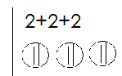 Multiply

a. 3 x 2

**6**

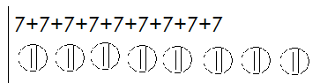b. 9 x 7

9 x 7

**63**

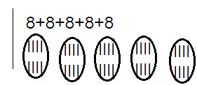

c. 5 x 8

5 x 8

**= 40**

**Activity**

Multiply the following numbers

1. 3 x 9

2. 4 x 7

3. 2 x 3

4. 1 x 5

5. 7 x 6

6. 9 x 7

7. 8 x 3

8. 6 x 2

9. 5 x 7

10. 9 x 1

11. 4 x 8

12. 8 x 2

**WORD PROBLEMS INVOLVING MULTIPLICATION OF NUMBERS**

**Key words**

- Multiply - multiple

- Times

- Product

**Examples**

1. A spider has **8** legs. How many legs do **3** spiders have?

**Solution**

One spider has **8** legs

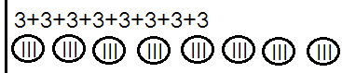 **3** spiders have (**8 x 3**) legs

**= 24 legs**

2. 1 book costs sh. 700. Find the cost of 4 similar books

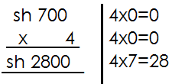 **Solution**

1 book costs sh. 700

4 books cost sh. 700 x 4

**Activity**

1. A pupil walks **3**km every day. How km does the pupils cover in **9** days?

2. A home uses **9** litres of milk a day. How many litres does the home use in **8** days?

3. A car has **8** wheels. How many wheels are there on **7** cars?

4. A car carries6 people. How many people are carried by **9** cars?

5. One pen costs sh. **900**. Find the cost of **5** pens.

6. One book has **8** pages. How many pages do **6** similar books have?

7. What is the product of **6** and **7**?

8. **3kg** of sugar were given to each family. If there were **9** family. How many kilograms were given out altogether?

9. Multiply **8** by **3**.

**MULTIPLICATION OF 2 DIGIT NUMBER BY 1 DIGIT WITHOUT CARRYING**

**Examples.**

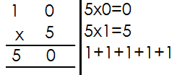1. **Multiply 10 x 5**

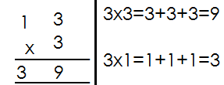2. **Multiply 13 x 3**

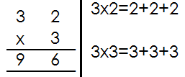3 .**Multiply 32 x 3**

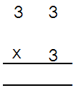 **Activity**

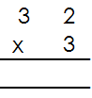 **Multiply the following** 8.

1. 24 x 3 6.

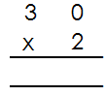2. 30 x 3

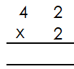3. 20 x 4 7. 9.

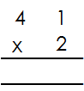4. 14 x 2

5.

**WORD PROBLEMS INVOLVING MULTIPLICATION OF 2 DIGIT NUMBER BY 1 DIGIT WITHOUT REGROUPING.**

**Examples**

1. One year has **12** months. How many months are in **4** years?

**Solution**

1 year_______12 months

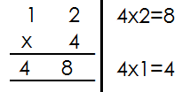 4 years--------- (12x4) months

**4** years have **48** months.

2. What is the product of **13** and **3**?

**Solution**

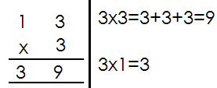 13x3

**Activity**

1. A car has **4** wheels. How many wheels are there on **20** cars?

2. One set contains **12** pencils. How many pencils do **4** similar sets contain?

3. A stool has **3** legs. How many legs do **33 s**tools have?

4. What is the product of **42** and **3**?

5. Multiply **30** by **4**

6. How many days are in **11** weeks?

7. There are **5** books in a box. How many books are there in **30** boxes?

8. A school uses **102** boxes of chalk in a month. How many boxes use in **4** months?

**MULTIPLICATION OF 2 BY 1 DIGITS WITH REGROUPING**

**Examples**

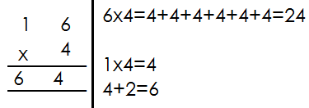1. Multiply 16 x4

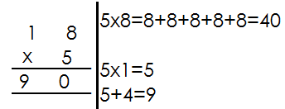2. Multiply: 18x5

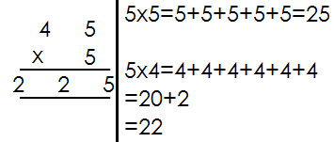3. Multiply 45 x5

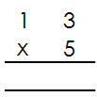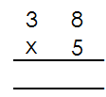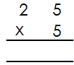 Multiply the following

1. 2. 3.

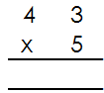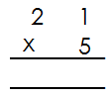

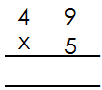 5. 6.

4.

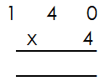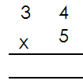 9.

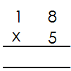 8.

7.

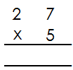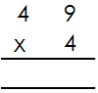

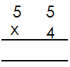 11. 12.

10.

**WORD PROBLEMS INVOLVING MULTIPLICATION WITH REGROUPING**

**Examples**

1. Alice sells **40kg** of sugar every day. How many kgs are sold in **4** days?

In **1** day, she sells------ **40** kgs

In **4** days, she sells-------**40kg x 4**

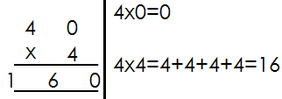

2. What is the product of **27** and **4**?

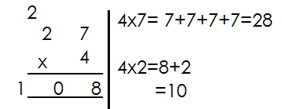 **27 x 4**

3. Multiply **46** by **3**

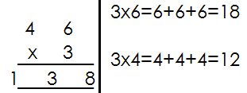 **46 x 3**

**Activity**

**Read and multiply**

1. One box holds **18** plates. How many plates will **7** boxes hold?

2. There are **84** stools with **3** legs each. What is the total number of legs?

3. One car carries **65** bags. How many bags do **5** cars carry?

4. What is the product of 148 and 5?

5. Multiply **23** by **5**?

6. **14** boxes are arranged in one line. If there are **9** lines. How many boxes are there altogether?

7. Multiply **507** by **6**

8. One cow has **4** legs. How many legs do **25** cows have?

9. Eight buses were used to take children for a trip. Each bus carried **32** pupils. How many pupils went for the trip?

**MULTIPLYING 3 BY 1 DIGIT WITH REGROUPING**

**Examples**

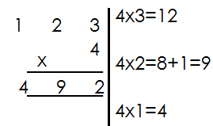1. Multiply: 23 x 4

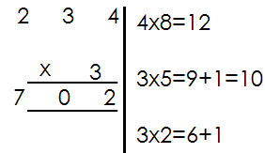2. Multiply: 234 x 3

**Activity**

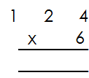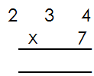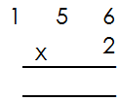 Multiply the following

1. 2. 3.

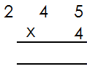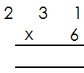

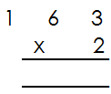 5. 6.

4.

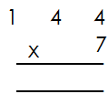

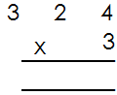 9.

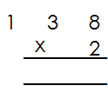 8.

7.

**MULTIPLY 4 DIGIT NUMBER BY 1 DIGIT WITH REGROUPING**

**Examples**

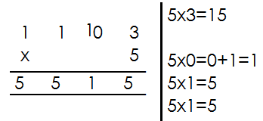1. Multiply: 1103 x 5

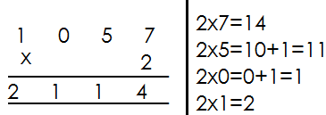2. Multiply: 1057 x 2

**Activity**

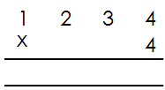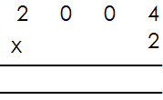 Multiply the following

1. 6.

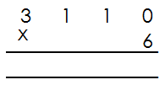

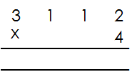 7.

2.

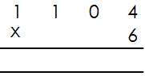

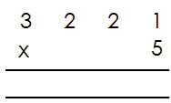

3. 4.

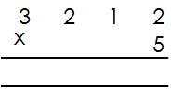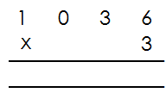5. 6.

**DIVISION OF WHOLE NUMBERS**

**Dividing numbers using repeated subtraction**

**Examples**

Workout **12 ÷ 3** using repeated subtraction

12 ÷ 3

12 - 3 =9

9 - 3 = 6

6 – 3 = 3

3 – 3 = 0

**4** times of subtraction

**Therefore 12 ÷ 3 =4**

2. Use repeated subtraction to workout

28 ÷ 4

28 ÷ 4

28 – 4 = 24

24 – 4 = 20

20 – 4 = 16

16 – 4 = 12

12 – 4 = 8

8 - 4 = 4

4 – 4 = 0

7 times of subtraction

Therefore 28 ÷ 4=7

**Activity**

Workout the division statement below using repeated subtraction

1. 9 ÷ 3

2. 10 ÷ 5

3. 20 ÷ 4

4. 18 ÷ 3

5. 27 ÷ 3

6. 40 ÷ 5

7. 50 ÷ 10

8. 36 ÷ 4

9. 15 ÷ 3

10. 12 ÷ 3

**DIVIDING 1 DIGIT NUMBER BY 1 DIGIT NUMBER USING LONG DIVISION WITH REMAINDERS**

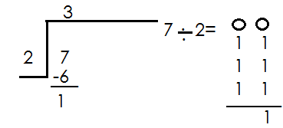 **Examples**

1.

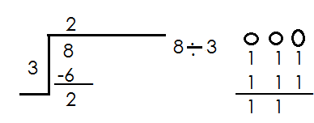 Therefore 7 ÷ 3=3 remainder 1

2.

Therefore 8÷3= 2 remainder 2

**Activity**

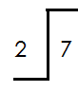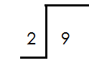 Divide numbers with remainders

1. 3.

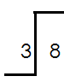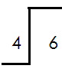

2. 4.

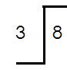

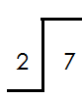5. 6.

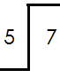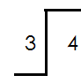

7**.** 8.

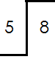

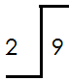9. 10.

**DIVIDING 2 DIGIT NUMBER BY 1 DIGIT NUMBER WITH REMAINDERS**

**Examples**

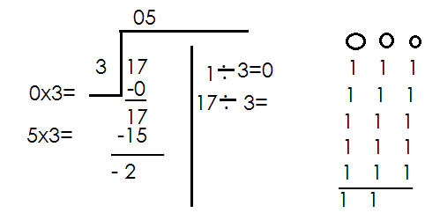1. Divide: 17 ÷ 3

**Therefore 17÷ 3=5 remainder 2**

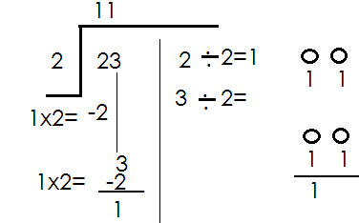2. Divide 23 ÷ 2

**Therefore 23 ÷ 2 = 11 remainder 1**

**Activity**

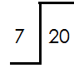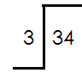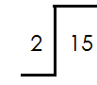Divide the numbers with remainders

1. 6. 7.

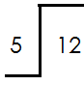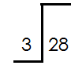

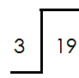3. 8.

2.

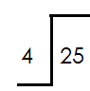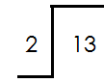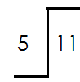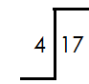

4. 5. 9. 10.

**DIVIDING 1 DIGIT NUMBER BY 1 DIGIT WITHOUT REMAINDERS**

**A. Without using long division**

1. Divide: 6 ÷ 6

6 - 6

=1

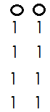2. Divide: 8 ÷ 2

8 ÷ 2

**= 4**

**Activity**

**Divide without using long division**

1. 9 ÷ 3

2. 6 ÷ 2

3. 5 ÷ 5

4. 4 ÷ 2

5. 6 ÷ 3

6. 8 ÷ 4

7. 4 ÷ 2

8. 7 ÷ 7

9. 9 ÷ 3

10. 8

B. **Using algorithm method( long division sign)**

**Examples**

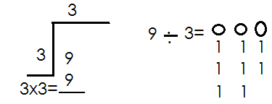1. Divide: 9 ÷ 3

9 ÷ 3 = 3

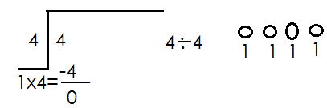2. Divide: 4 ÷ 4

4 ÷4 =1

**Activity**

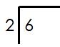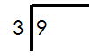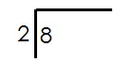**Divide 1 by 1 without remainders using long division.**

1. 2. 3. 4.



5. 6. 7. 8.



9. 10.

**DIVIDING 2 DIGIT NUMBER BY 1 DIGIT NUMBER WITHOUT REMAINDER USING LONG DIVISION**

**Examples**

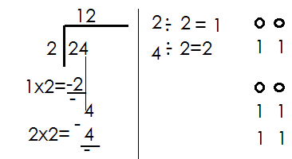1. Divide: 24 ÷ 2

**Therefore 24 ÷ 2=12**

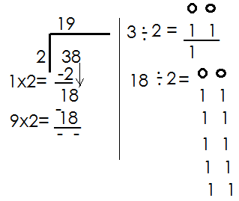2. **Divide:** 38 ÷ 2 = 19

Therefore 38 ÷ 2=19

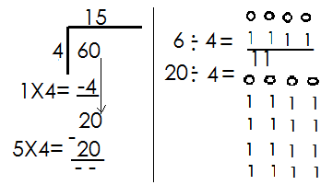3. Divide: 60 ÷ 4 = 15

Therefore 60 ÷ 4 =15

**Activity**

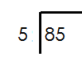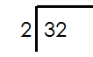Divide the following using long division

1. 5.

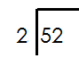

2. 6.



3. 7.

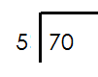

4. 8.

**WORD PROBLEMS INVOLVING DIVIDING 2 DIGIT NUMBER BY 1 DIGIT NUMBERS.**

Key words

Divide

Share

Quotient

**Examples**

1. Share 36 pens equally among 6 pupils

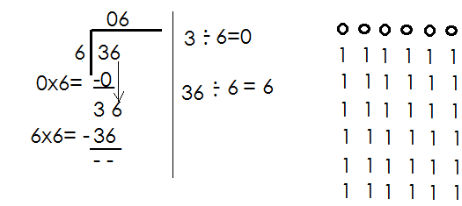 36 ÷ 6

Each pupil gets **6** pens

2. Share **24** balls equally among **4** schools. How many does each school get?

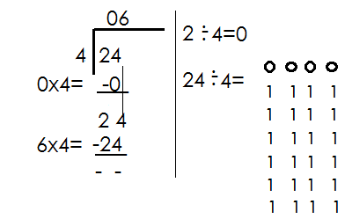 24 balls ÷ 4

Each school gets 6 balls

**Activity**

1. Share **12** oranges among **3** children. How many does each child get?

2. Divide **45** by **5**

3. What is the quotient of **76** and **2**?

4. Divide **54** by **3**

5. There were **42** desks to be shared equally among **3** classes. How many did each class get?

6. Lumonde got **55** eggs from his farm. If each hen laid **7** eggs, how many hens does he have?

7. How many weeks are in **35** days?

8. Find he quotient of **60** and **3**.

9. Share **18** cups equally between two girls. How many does each get?

10. Musoke had **20** pencils had shared them equally among **5** boys. How many did each boy get?

**DIVIDING 3 DIGIT BY 1 DIGIT WITHOUT REMAINDER**

**Examples**

1. Divide: 468 ÷ 2

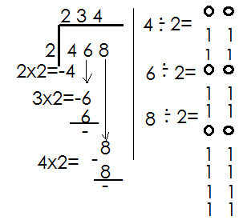

Therefore 468 ÷2=234

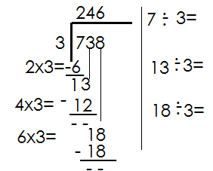**2.**  Divide: 738 ÷ 3

Therefore 738 ÷ 3=246

3. Divide: 128 ÷ 4.

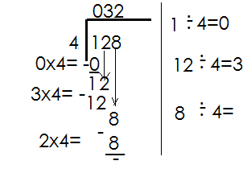

Therefore 128 ÷ 4=32

**Activity**

Divide the following

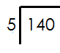

1. 5.

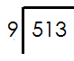

6.

2.

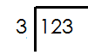7.

3.

 8.

4.

9.

**WORD PROBLEMS INVOLVING DIVIDING 3 BY 1 DIGIT NUMBERS**

**Examples**

1. Share **176** books equally among **8** streams. How many books does each stream get?

**176** books ÷ **8**

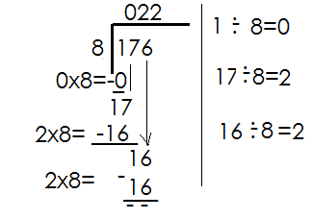

Each stream gets 22 books.

2. Find the quotient of 384 and 3

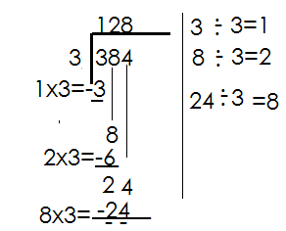 384 ÷ 3

Therefore, the quotient of 384 and 3 is 128.

**Activity**

1. Divide 145 ÷ 5

2. What is the quotient of 252 and 7?

3. Divide **318** by **3**

4. A box contained **505** pencils to be given to 5 schools. How many pencils did each school get?

5. **128** sweets are to be shared equally to **8** children. What does each get?

6. There were **434** desks to be shared among **7** classes. How many desks did each get?

**ADDING NUMBERS USING A NUMBER LINE**

**Examples**

1. Add **3 + 4** using a number line

 **3 + 4 = 7**

2. Use a number line to add **3 + 1**

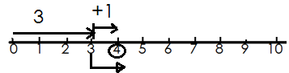 **3 +1 = 4**

3. Workout 7+2 on a number line

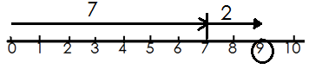 **7+2 = 9**

**Activity**

**Add the following numbers using a number line**

1. 2 + 4 = 6. 1 + 3 =

2. 0 + 4 = 7. 6 + 5 =

3. 1 + 5 = 8. 6 + 2 =

4. 4 + 4 = 9. 8 + 2 =

5. 8 + 1 = 10. 1 + 7 =

**SUBTRACTING NUMBERS USING A NUMBER LINE.**

**Examples**

1. Subtract **8** from **10** using a number line

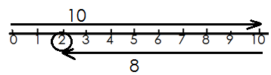 **10 – 8 = 2**

2. What is 5-3 using a number line

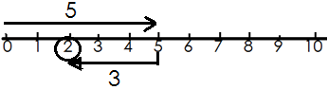 **5 – 3 = 2**

3. Use a number line to subtract 4-0

4 – 0 = 4



**Activity**

**Use a number line to subtract the following numbers**

1. 6 – 3 = 6. 11 – 7 =

2. 10 – 7 = 7. 5 – 4 =

3. 4 – 1 = 8. 9 – 3 =

4. 7 – 2 = 9. 6 – 5 =

5. 12 – 8 = 10. 3 – 1 =

**MULTIPLYING 1 DIGIT NUMBER BY 1 DIGIT NUMBER USING A NUMBER LINE**

**Examples**

1. Workout **3 x 2** on a number line

 **3 x 2 = 6**

2. Multiply **2 x 2** using a number line.

 **2 x 2 = 4**

3. What is 3x3 on a number line?

 **3 x 3 = 9**

**Activity**

Multiply the following numbers using number lines

1. 5 x 2 = 4. 3 x 2 =

2. 1 x 6 = 5. 6 x 2 =

3. 3 x 4 = 6. 1 x 4 =

7. 6 x 2 = 8. 1 x 7 =

9. 4 x 2 = 10. 2 x 2 =

**PATTERNS AND SEQUENCES**

**Even numbers;**

Are numbers that have no remainder when divided by 2

i.e. 2, 4, 6, 8, 10, 12, 14, 16, ______

**Odd numbers**

Odd numbers are numbers that cannot be exactly divided by 2.

i.e. 1.3,5, 7, 9, 11, 13, 15, 17, _________________

NB. 3 ÷ 2 = 1 remainder1

**Reference: Understanding math bk 3 pg 40**.

**Mk Maths bk 4 pg 58- 63.**

**Primary maths for Uganda bk 3 page 80.**

**Exercise**

1. Complete correctly.

a) 1, 3, 5, __, __, ___, ___

b) 5, __, ___, ___, ____

c) 7, 9, __, ___, ___, ____

d) 11, 13, 15, __, ___, ___, ___

e) 11, 9, 7, __, ___, ____

**COUNTING OR NATURAL NUMBERS**

Counting numbers are numbers we use to count.

They include; 1, 2, 3, 4, 5, 6, 7, 8, 9, 10, 11, 12, 13…

**Whole numbers**

Whole numbers are counting numbers that include 0.

Example: 0, 1, 2, 3, 4, 5, 6, 7, 8, 9, 10, 11, 12, 13,

References: understanding maths Bk. 3 pg. 40

MK maths BK. 4 PG. 58 – 63

Primary maths for Uganda Bk. 3 pg. 80

Exercise

1. Fill in correctly.

a) 0, 1, 2, 3, 4, ___,____

b) 2, 3, 4, 5, __,__

**MULTIPLES OF NATURAL NUMBERS**

**Learning activity**

A multiple is a result of multiplying a given number by another counting number.

Keep adding a given number to the result to get the next number.

Multiples of;

2. M2 = {2, 4, 6, 8, 10, 12, 14, 16, 18, 20, 22…}

4. M4 = {4, 8, 12, 16, 20, 24, 28, 32, 36, 40 …}

10. M10 = {10, 20, 30, 40, 50, 60, 70, 80...}

Exercise

Find the multiples of the following.

a) 3 b) 5 c) 6

**FINDING LCM**

Find the L.C.M of 2 and 3

M2 = {2, 4, 6, 8, 10, 12…}

M3 = {3, 6, 9, 12, 15 …}

LCM of 2 and 3 = 6

Activity

MK Maths Bk. 4 PG. 64, 65 and 73.

**MAGIC SQUARE**

Teaching learning activity

Each row, column and diagonal adds up to the same number called magic number.

Example

|  |  |  |
| --- | --- | --- |
| 6 | 1 | 8 |
| a | 5 | 3 |
| 2 | c | B |

c + 5 + 1 = 15

c + 6 – 6 = 15 - 6

c = 9

b + 3 + 8 = 15

b + 11 – 11 = 15 - 11

b = 4

Magic total = 2 + 5 + 8

a + 8 – 8 = 15 – 8

a = 7

**Activity**

Primary school maths pg. 110

MK Maths Bk. 3 pg. 87

**END**